**Roll No:-**49

**Practical no:-**1

**Practical Name:-**Setup a GitHub Account and send the email message to friend telling to your friend about the account

* **Create a GitHub account :**

If you don't already have a GitHub account, here's how to create one.

1. Open [https://github.com](https://github.com/) in a web browser, and then select **Sign up**

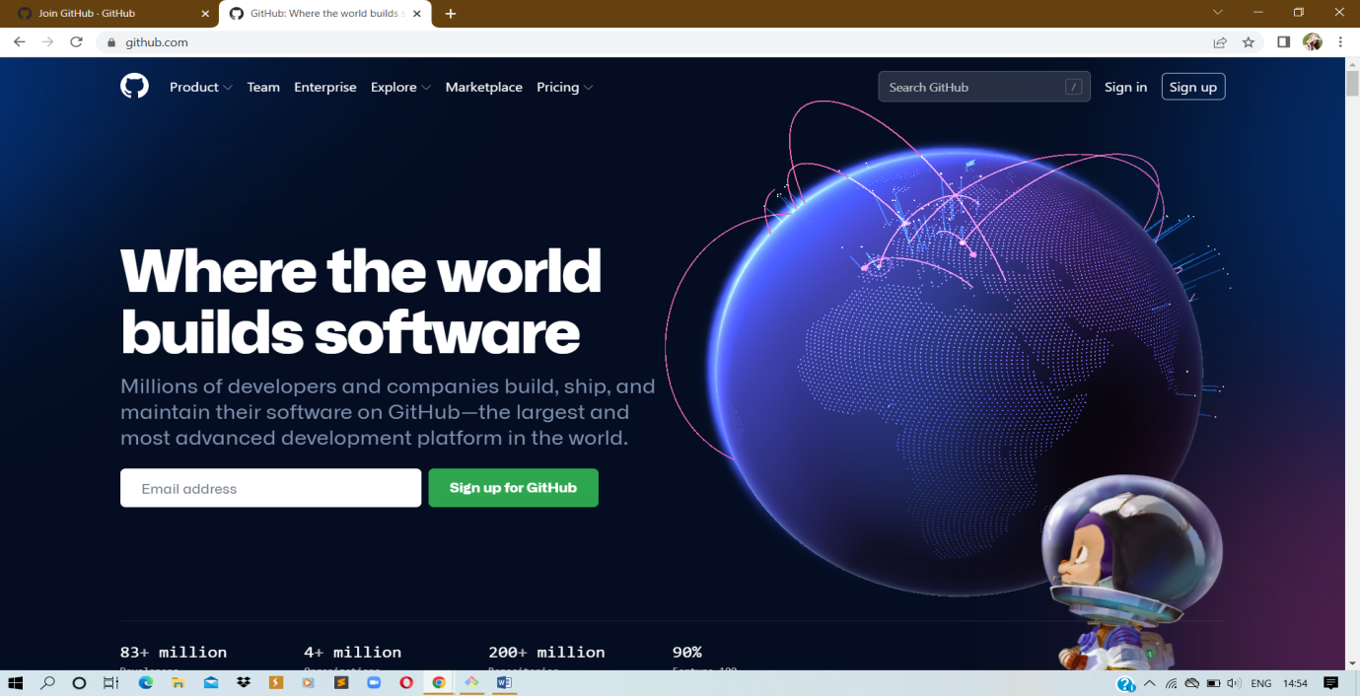

1. **Enter your email** address:

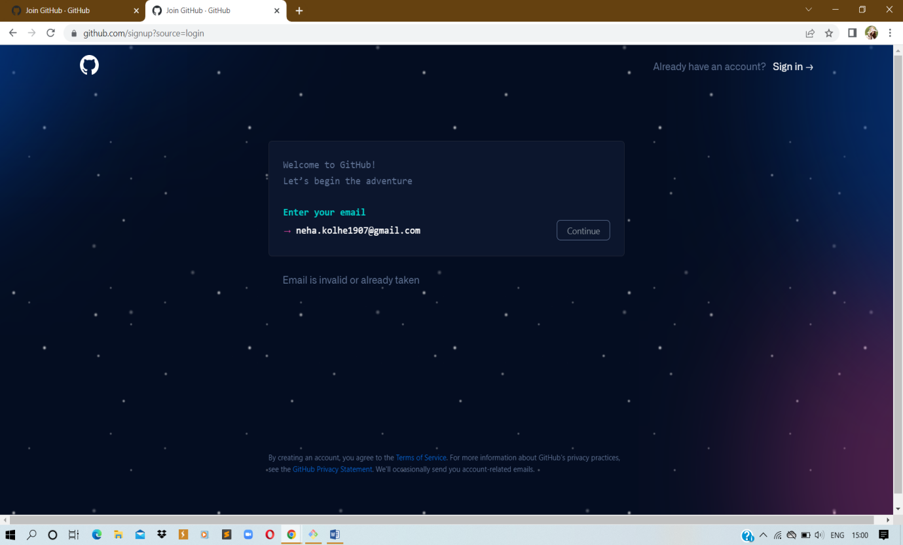

1. **Create a password** for your new GitHub account, and **Enter a username**, too. Next, choose whether you want to receive updates and announcements via email, and then select **Continue**.

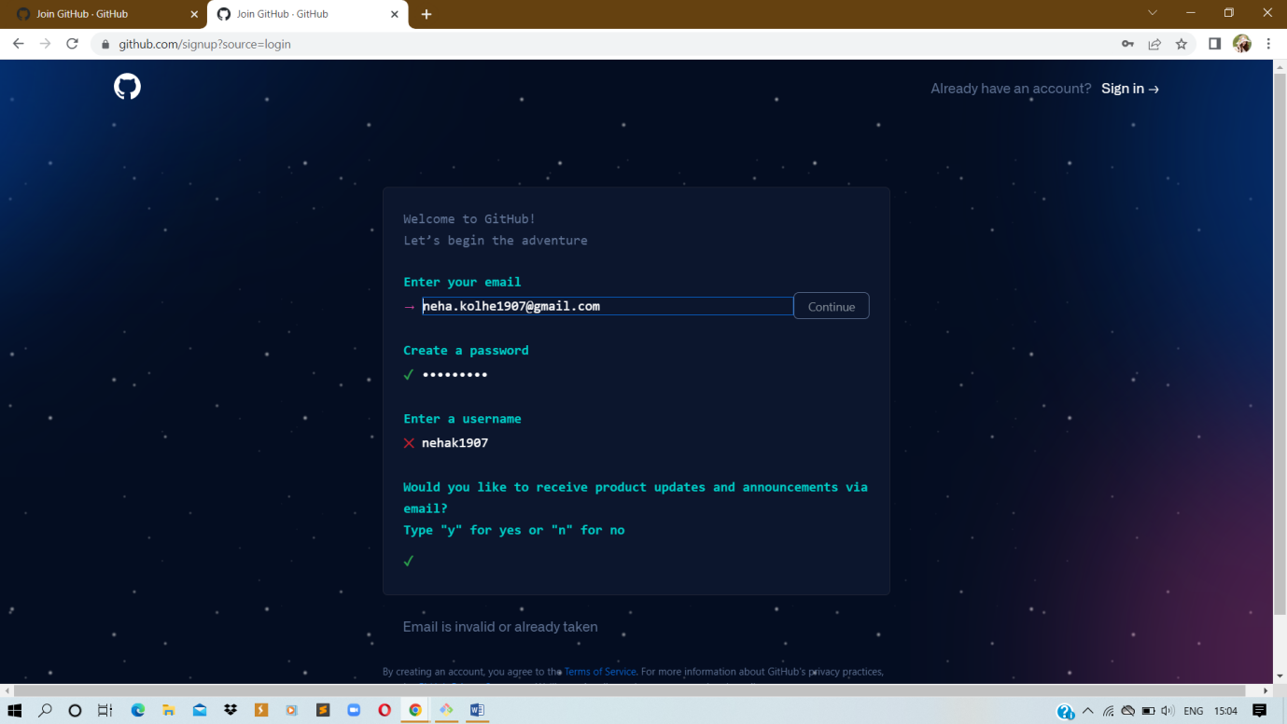

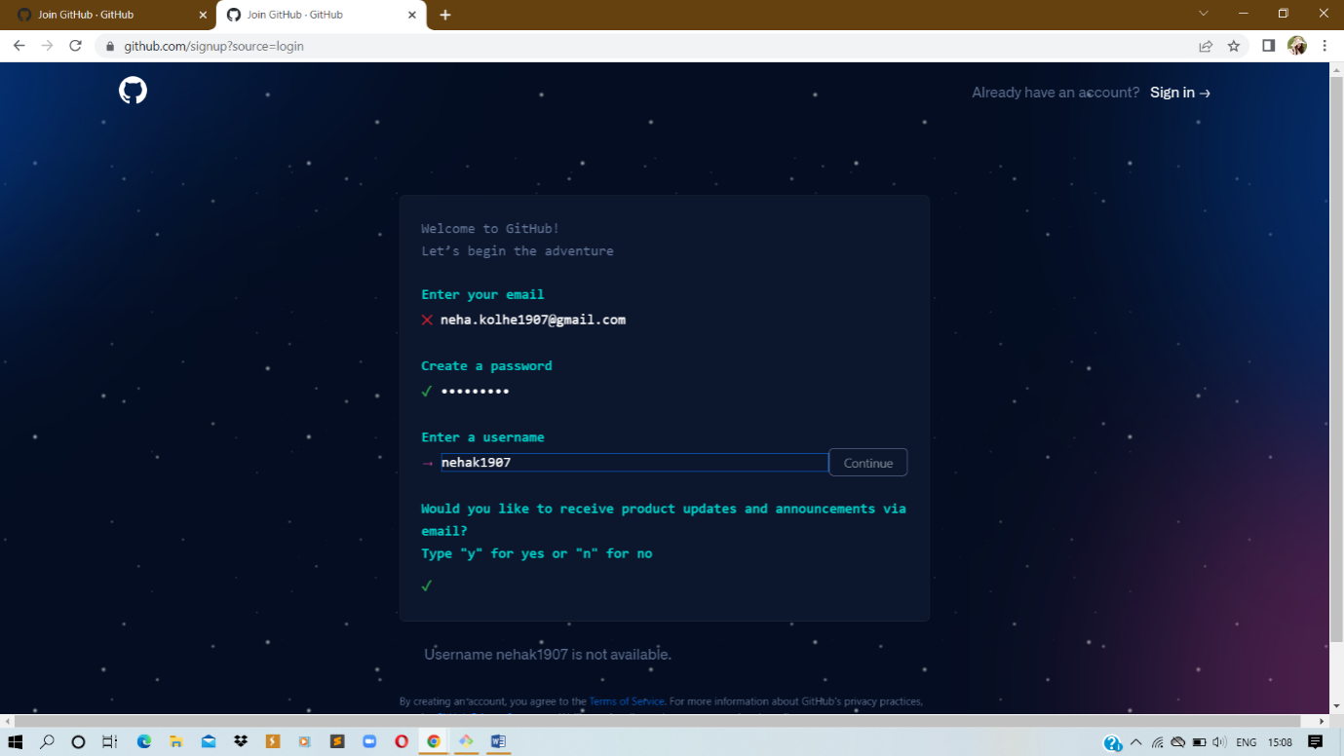

1. **Verify your account** by solving a puzzle. Select the **Start Puzzle** button to do so, and then follow the prompts
2. After you verify your account, select the **Create account** button.
3. Next, GitHub sends a launch code to your email address. Type that launch code in the **Enter code** dialog, and then press **Enter**.

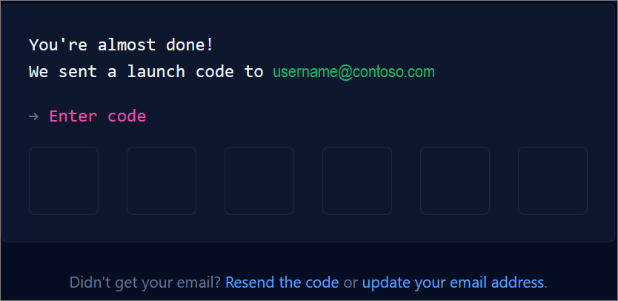

1. GitHub asks you some questions to help tailor your experience. Choose the answers that apply to you in the following dialogs:
   1. **How many team members will be working with you?**
   2. **What specific features are you interested in using?**
2. On the **Where teams collaborate and ship** screen, you can choose whether you want to use the Free account or the

Team account. To choose the **Free** account, select the **Skip personalization** button.

GitHub opens a personalized page in your browser.

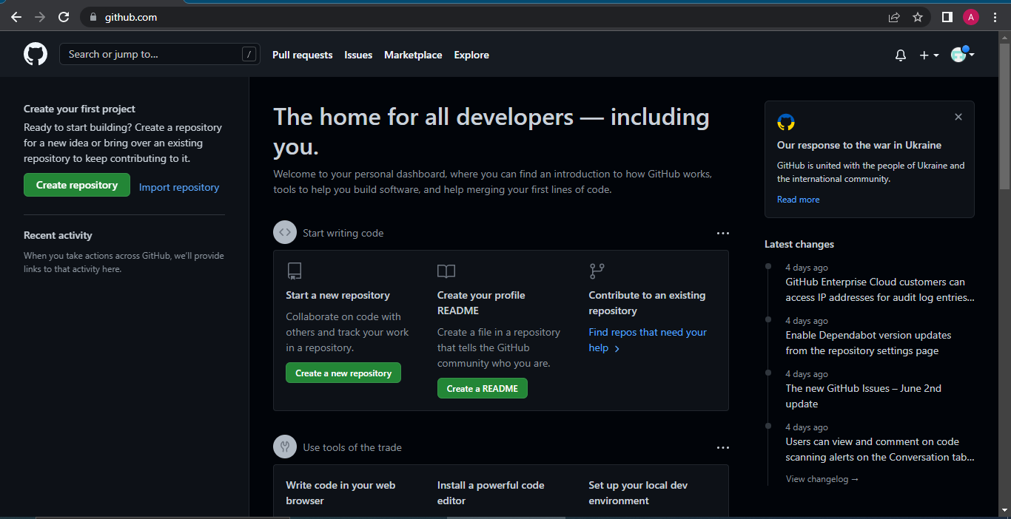

Congratulations! You've successfully created your GitHub account.

* **Paste the screen shots of email which you had sended to your friend through Github**

**Step1:** Go to Github account and login.

**Step2:** After login, click on any created remote repository.

**Step3:** Go to settings of that particular remote repository and click on Email notifications and add the email id of your friend which you had to send the mail.

**Step4:** Make changes on your remote repository by editing any existing file or you can create any new file also.

**Step5:** Now, tell your friend to check his/her mail id by login.

* **Screenshort of mail:-**

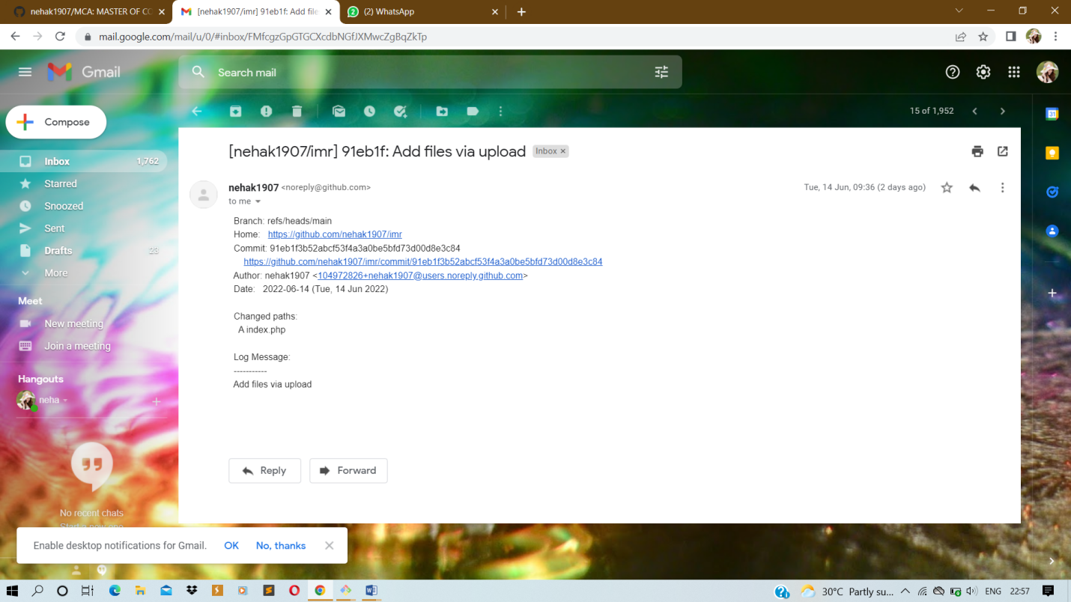

**Roll No:-**49

**Practical no:-**2

**Practical Name:-**clone the repository at <https://github.com/KBCNMU>

NEHA@LAPTOP-CAC84G1B MINGW64 ~

$ git --version

git version 2.29.0.windows.1

NEHA@LAPTOP-CAC84G1B MINGW64 ~

$ git --help

usage: git [--version] [--help] [-C <path>] [-c <name>=<value>]

[--exec-path[=<path>]] [--html-path] [--man-path] [--info-path]

[-p | --paginate | -P | --no-pager] [--no-replace-objects] [--bare]

[--git-dir=<path>] [--work-tree=<path>] [--namespace=<name>]

<command> [<args>]

These are common Git commands used in various situations:

start a working area (see also: git help tutorial)

clone Clone a repository into a new directory

init Create an empty Git repository or reinitialize an existing one

work on the current change (see also: git help everyday)

add Add file contents to the index

mv Move or rename a file, a directory, or a symlink

restore Restore working tree files

rm Remove files from the working tree and from the index

sparse-checkout Initialize and modify the sparse-checkout

examine the history and state (see also: git help revisions)

bisect Use binary search to find the commit that introduced a bug

diff Show changes between commits, commit and working tree, etc

grep Print lines matching a pattern

log Show commit logs

show Show various types of objects

status Show the working tree status

grow, mark and tweak your common history

branch List, create, or delete branches

commit Record changes to the repository

merge Join two or more development histories together

rebase Reapply commits on top of another base tip

reset Reset current HEAD to the specified state

switch Switch branches

tag Create, list, delete or verify a tag object signed with GPG

collaborate (see also: git help workflows)

fetch Download objects and refs from another repository

pull Fetch from and integrate with another repository or a local branch

push Update remote refs along with associated objects

'git help -a' and 'git help -g' list available subcommands and some

concept guides. See 'git help <command>' or 'git help <concept>'

to read about a specific subcommand or concept.

See 'git help git' for an overview of the system.

NEHA@LAPTOP-CAC84G1B MINGW64 ~

$ git clone https://github.com/nehak1907/KBCNMU.git

Cloning into 'KBCNMU'...

remote: Enumerating objects: 3, done.

remote: Counting objects: 100% (3/3), done.

remote: Compressing objects: 100% (2/2), done.

remote: Total 3 (delta 0), reused 0 (delta 0), pack-reused 0

Receiving objects: 100% (3/3), done.

**OUTPUT:-**

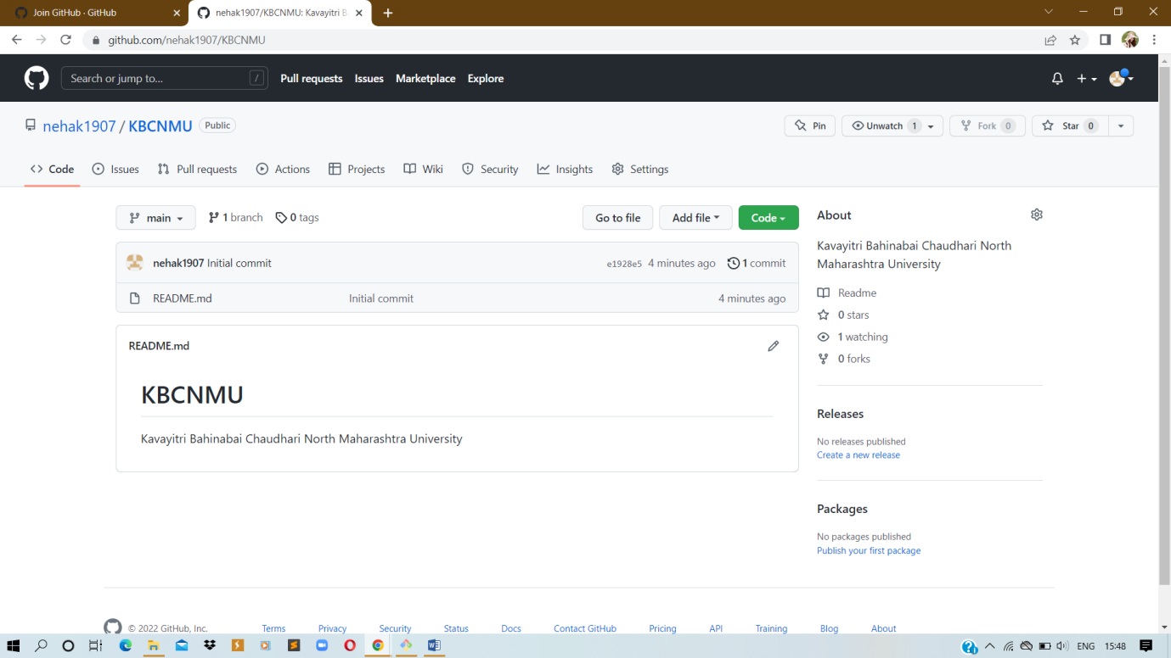

**Roll No:-**49**

**Practical no:-**3

**Practical Name:-** Use git add that file to the primary repository . use git commit your change.

NEHA@LAPTOP-CAC84G1B MINGW64 ~

$ git clone https://github.com/nehak1907/MCA1.git

Cloning into 'MCA1'...

remote: Enumerating objects: 3, done.

remote: Counting objects: 100% (3/3), done.

remote: Total 3 (delta 0), reused 0 (delta 0), pack-reused 0

Receiving objects: 100% (3/3), done.

NEHA@LAPTOP-CAC84G1B MINGW64 ~

$ cd MCA1

NEHA@LAPTOP-CAC84G1B MINGW64 ~/MCA1 (main)

$ git init MCA1

Initialized empty Git repository in C:/Users/NEHA/MCA1/MCA1/.git/

NEHA@LAPTOP-CAC84G1B MINGW64 ~/MCA1 (main)

$ touch file1.txt

NEHA@LAPTOP-CAC84G1B MINGW64 ~/MCA1 (main)

$ git add file1.txt

NEHA@LAPTOP-CAC84G1B MINGW64 ~/MCA1 (main)

$ git commit -m "if..... else statement"

[main eace73c] if..... else statement

1 file changed, 0 insertions(+), 0 deletions(-)

create mode 100644 file1.txt

NEHA@LAPTOP-CAC84G1B MINGW64 ~/MCA1 (main)

$ git config --global user.name"nehak1907"

NEHA@LAPTOP-CAC84G1B MINGW64 ~/MCA1 (main)

$ git config --global user.email[neha.kolhe1907@gmail,com](mailto:neha.kolhe1907@gmail,com)

NEHA@LAPTOP-CAC84G1B MINGW64 ~/MCA1 (main)

$ git commit --m "if.....else"

[main f5f22f7] if.....else

1 file changed, 0 insertions(+), 0 deletions(-)

create mode 100644 file1.txt

**OUTPUT:-**

* **AFTER ADD:-**

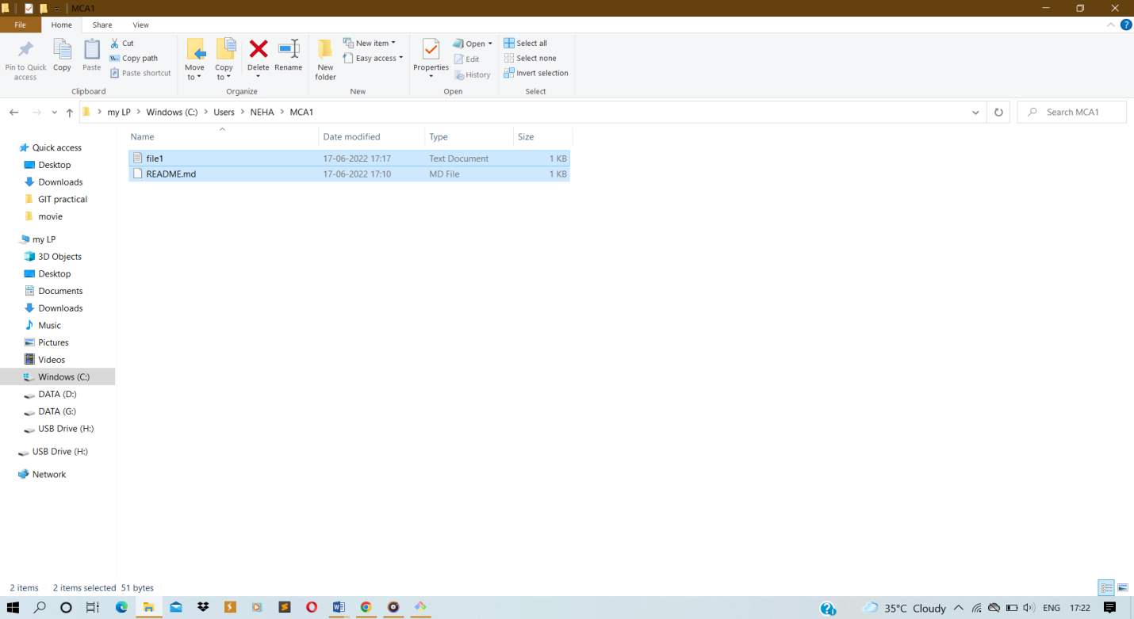

* **BEFORE ADD:-**

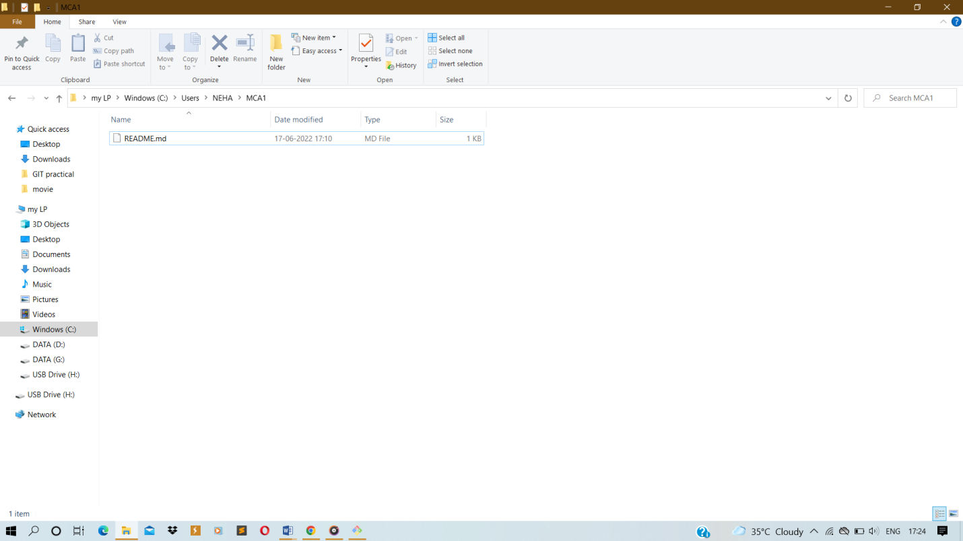

**Roll No:-**49

**Practical no:-**4

**Practical Name:-**Use git push to send your change to the primary repository . look online to see if your change has been pushed.

NEHA@LAPTOP-CAC84G1B MINGW64 ~

$ git clone https://github.com/kneha1907/KBCNMU.git

Cloning into 'KBCNMU'...

remote: Enumerating objects: 3, done.

remote: Counting objects: 100% (3/3), done.

remote: Compressing objects: 100% (2/2), done.

remote: Total 3 (delta 0), reused 0 (delta 0), pack-reused 0

Receiving objects: 100% (3/3), done.

NEHA@LAPTOP-CAC84G1B MINGW64 ~

$ cd KBCNMU

NEHA@LAPTOP-CAC84G1B MINGW64 ~/KBCNMU (main)

$ ls

README.md

NEHA@LAPTOP-CAC84G1B MINGW64 ~/KBCNMU (main)

$ git init KBCNMU

Initialized empty Git repository in C:/Users/NEHA/KBCNMU/KBCNMU/.git/

NEHA@LAPTOP-CAC84G1B MINGW64 ~/KBCNMU (main)

$ touch nk.txt

NEHA@LAPTOP-CAC84G1B MINGW64 ~/KBCNMU (main)

$ git add nk.txt

NEHA@LAPTOP-CAC84G1B MINGW64 ~/KBCNMU (main)

$ ls

KBCNMU/ nk.txt README.md

NEHA@LAPTOP-CAC84G1B MINGW64 ~/KBCNMU (main)

$ git commit -m"forth practical"

[main f7bd643] forth practical

1 file changed, 0 insertions(+), 0 deletions(-)

create mode 100644 nk.txt

NEHA@LAPTOP-CAC84G1B MINGW64 ~/KBCNMU (main)

$ git config --global user.name"kneha1907"

NEHA@LAPTOP-CAC84G1B MINGW64 ~/KBCNMU (main)

$ git config --global user.gmail"kolheneha1907@gmail.com"

NEHA@LAPTOP-CAC84G1B MINGW64 ~/KBCNMU (main)

$ git push -u origin

Enumerating objects: 4, done.

Counting objects: 100% (4/4), done.

Delta compression using up to 8 threads

Compressing objects: 100% (2/2), done.

Writing objects: 100% (3/3), 274 bytes | 137.00 KiB/s, done.

Total 3 (delta 0), reused 0 (delta 0), pack-reused 0

To https://github.com/kneha1907/KBCNMU.git

ee6bf8b..f7bd643 main -> main

Branch 'main' set up to track remote branch 'main' from 'origin'.

* **OUTPUT**
* **AFTER PUSH**

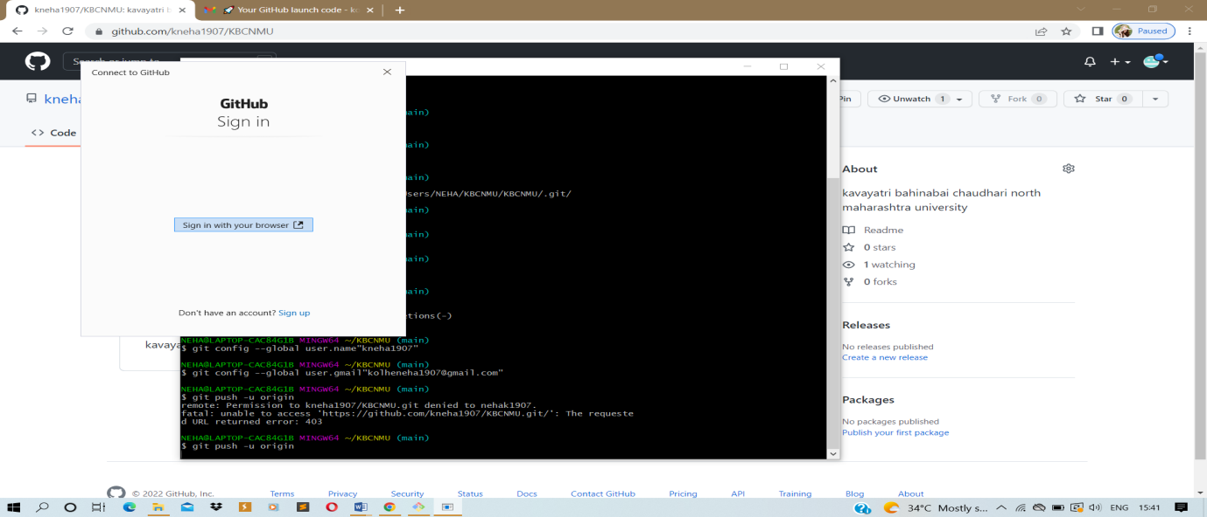

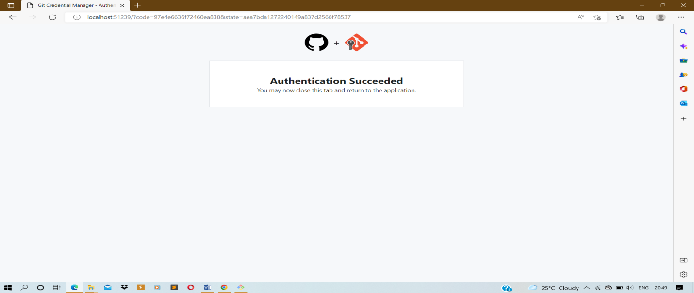

* **PUSH:BEFORE -**

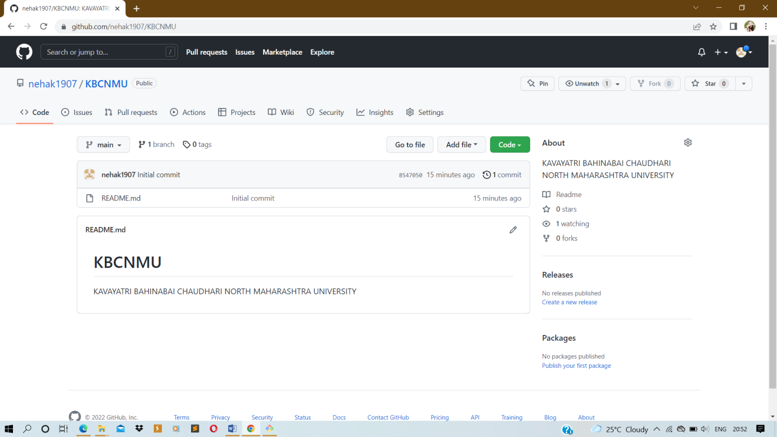

**Roll No:-**49

**Practical no:-**5

**Practical Name:-**Use git pull to get your parters change into your repository. Verify that you have the new file

comp@DESKTOP-HKJ9SS8 MINGW64 ~

$ git clone https://github.com/nehak1907/imr.git

Cloning into 'imr'...

remote: Enumerating objects: 3, done.

remote: Counting objects: 100% (3/3), done.

remote: Total 3 (delta 0), reused 0 (delta 0), pack-reused 0

Receiving objects: 100% (3/3), done.

comp@DESKTOP-HKJ9SS8 MINGW64 ~

$ cd imr

comp@DESKTOP-HKJ9SS8 MINGW64 ~/imr (main)

$ git init imr

Initialized empty Git repository in C:/Users/comp/imr/imr/.git/

comp@DESKTOP-HKJ9SS8 MINGW64 ~/imr (main)

$ git pull https://github.com/nehak1907/imr.git

remote: Enumerating objects: 4, done.

remote: Counting objects: 100% (4/4), done.

remote: Compressing objects: 100% (3/3), done.

remote: Total 3 (delta 0), reused 0 (delta 0), pack-reused 0

Unpacking objects: 100% (3/3), 987 bytes | 49.00 KiB/s, done.

From https://github.com/nehak1907/imr

* branch HEAD -> FETCH_HEAD

Updating 631d491..91eb1f3

Fast-forward

index.php | 21 +++++++++++++++++++++

1 file changed, 21 insertions(+)

create mode 100644 index.php

* **OUTPUT:-\*\***

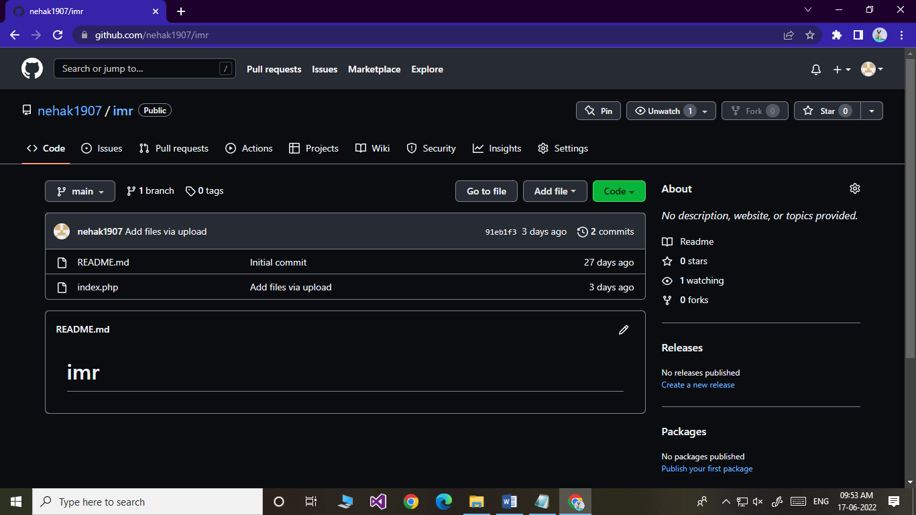

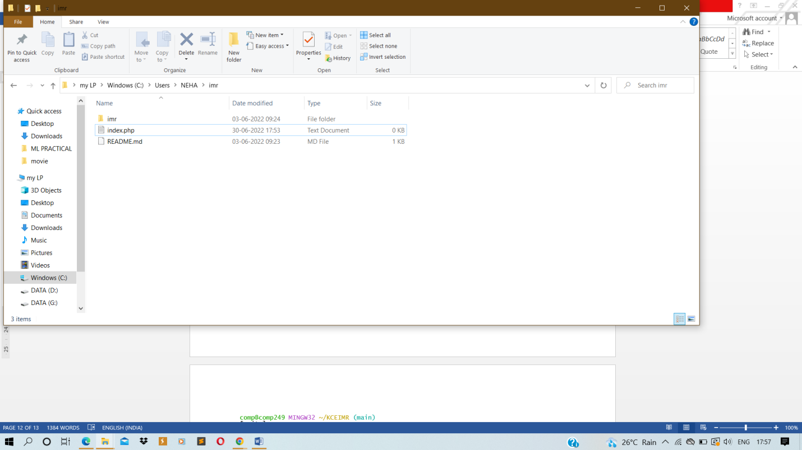

**Roll No:-**49

**Practical no:-**6

**Practical Name:-**Use gitlog or git log less to see a list of changes to the repository

comp@comp249 MINGW32 ~

$ git clone https://github.com/nehak1907/KCEIMR.git

Cloning into 'KCEIMR'...

remote: Enumerating objects: 3, done.

remote: Counting objects: 100% (3/3), done.

remote: Total 3 (delta 0), reused 0 (delta 0), pack-reused 0

Receiving objects: 100% (3/3), done.

comp@comp249 MINGW32 ~

$ cd KCEIMR

comp@comp249 MINGW32 ~/KCEIMR (main)

$ git log

commit e8a76c3e84c83d4a487ec4070e8b69995ccf3853 (HEAD -> main, origin/main, origin/HEAD)

Author: nehak1907 <104972826+nehak1907@users.noreply.github.com>

Date: Thu Jun 30 09:36:48 2022 +0530

Initial commit

comp@comp249 MINGW32 ~/KCEIMR (main)

$ git log --oneline

e8a76c3 (HEAD -> main, origin/main, origin/HEAD) Initial commit

**Output**:-

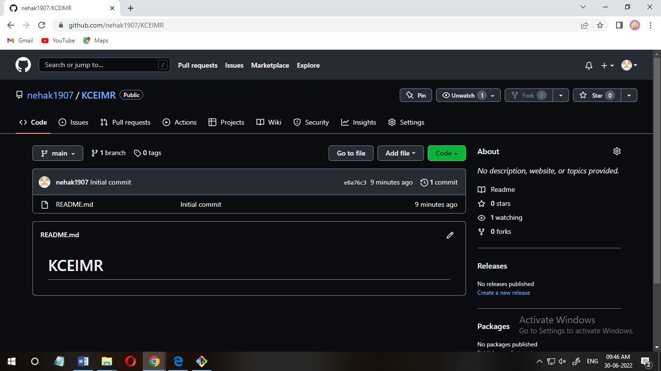

NEHA@LAPTOP-CAC84G1B MINGW64 ~

$ git clone https://github.com/nehak1907/imr.git

Cloning into 'imr'...

remote: Enumerating objects: 6, done.

remote: Counting objects: 100% (6/6), done.

remote: Compressing objects: 100% (4/4), done.

remote: Total 6 (delta 0), reused 0 (delta 0), pack-reused 0

Receiving objects: 100% (6/6), done.

NEHA@LAPTOP-CAC84G1B MINGW64 ~

$ cd imr

NEHA@LAPTOP-CAC84G1B MINGW64 ~/imr (main)

$ git log

commit 91eb1f3b52abcf53f4a3a0be5bfd73d00d8e3c84 (HEAD -> main, origin/main, origin/HEAD)

Author: nehak1907 <104972826+nehak1907@users.noreply.github.com>

Date: Tue Jun 14 09:36:05 2022 +0530

Add files via upload

commit 631d491dedbfbe0492eb4fa1469a9ffb4b62c109

Author: nehak1907 <104972826+nehak1907@users.noreply.github.com>

Date: Sat May 21 14:34:46 2022 +0530

Initial commit

NEHA@LAPTOP-CAC84G1B MINGW64 ~/imr (main)

$ git log --oneline

91eb1f3 (HEAD -> main, origin/main, origin/HEAD) Add files via upload

631d491 Initial commit

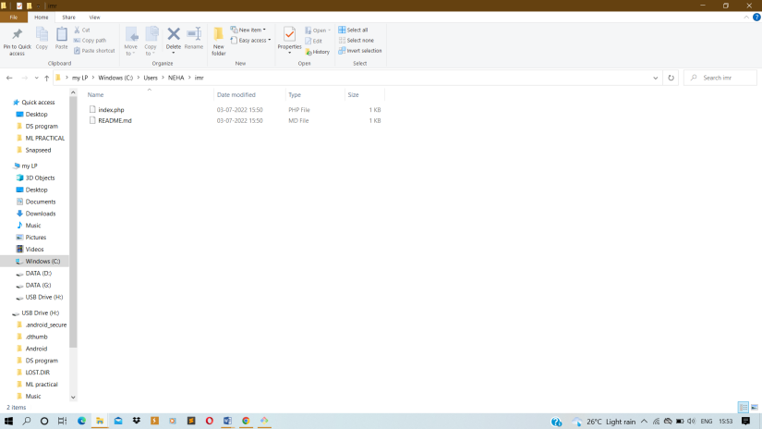

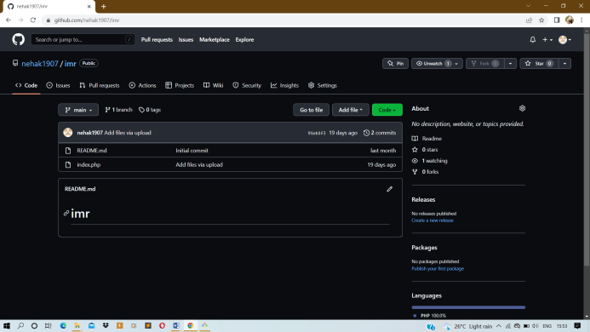

**Roll No:-**49

**Practical no:-**9

**Practical Name:-**Demonstrate the use of git diff command

NEHA@LAPTOP-CAC84G1B MINGW64 ~/imr (main)

$ git clone https://github.com/nehak1907/BSc.git

Cloning into 'BSc'...

remote: Enumerating objects: 3, done.

remote: Counting objects: 100% (3/3), done.

remote: Total 3 (delta 0), reused 0 (delta 0), pack-reused 0

Receiving objects: 100% (3/3), done.

NEHA@LAPTOP-CAC84G1B MINGW64 ~/imr (main)

$ git init

Reinitialized existing Git repository in C:/Users/NEHA/imr/.git

NEHA@LAPTOP-CAC84G1B MINGW64 ~/imr (main)

$ git status

On branch main

Your branch is up to date with 'origin/main'.

Untracked files:

(use "git add <file>..." to include in what will be committed)

BSc/

nothing added to commit but untracked files present (use "git add" to track)

NEHA@LAPTOP-CAC84G1B MINGW64 ~/imr (main)

$ git rm

fatal: No pathspec was given. Which files should I remove?

NEHA@LAPTOP-CAC84G1B MINGW64 ~/imr (main)

$ git rm https://github.com/nehak1907/BSc.git

fatal: pathspec 'https://github.com/nehak1907/BSc.git' did not match any files

NEHA@LAPTOP-CAC84G1B MINGW64 ~/imr (main)

$ git log

commit 91eb1f3b52abcf53f4a3a0be5bfd73d00d8e3c84 (HEAD -> main, origin/main, origin/HEAD)

Author: nehak1907 <104972826+nehak1907@users.noreply.github.com>

Date: Tue Jun 14 09:36:05 2022 +0530

Add files via upload

commit 631d491dedbfbe0492eb4fa1469a9ffb4b62c109

Author: nehak1907 <104972826+nehak1907@users.noreply.github.com>

Date: Sat May 21 14:34:46 2022 +0530

Initial commit

NEHA@LAPTOP-CAC84G1B MINGW64 ~/imr (main)

$ git show

commit 91eb1f3b52abcf53f4a3a0be5bfd73d00d8e3c84 (HEAD -> main, origin/main, origin/HEAD)

Author: nehak1907 <104972826+nehak1907@users.noreply.github.com>

Date: Tue Jun 14 09:36:05 2022 +0530

Add files via upload

**diff --git a/index.php b/index.php**

**new file mode 100644**

**index 0000000..8b83199**

**--- /dev/null**

**+++ b/index.php**

@@ -0,0 +1,21 @@

+<?php

+

+/**

+ * @file

+ * The PHP page that serves all page requests on a Drupal installation.

+ *

+ * The routines here dispatch control to the appropriate handler, which then

+ * prints the appropriate page.

+ *

+ * All Drupal code is released under the GNU General Public License.

+ * See COPYRIGHT.txt and LICENSE.txt.

+ */

+

+/**

+ * Root directory of Drupal installation.

+ */

+define('DRUPAL_ROOT', getcwd());

+

+require_once DRUPAL_ROOT . '/includes/bootstrap.inc';

+drupal_bootstrap(DRUPAL_BOOTSTRAP_FULL);

+menu_execute_active_handler();

NEHA@LAPTOP-CAC84G1B MINGW64 ~/imr (main)

$ git tag

NEHA@LAPTOP-CAC84G1B MINGW64 ~/imr (main)

$ git branch

* main

NEHA@LAPTOP-CAC84G1B MINGW64 ~/imr (main)

$ git checkout

Your branch is up to date with 'origin/main'.

NEHA@LAPTOP-CAC84G1B MINGW64 ~/imr (main)

$ git merge

Already up to date.

NEHA@LAPTOP-CAC84G1B MINGW64 ~/imr (main)

$ git remote

origin

NEHA@LAPTOP-CAC84G1B MINGW64 ~/imr (main)

$ git push -u origin

remote: Permission to nehak1907/imr.git denied to kneha1907.

fatal: unable to access 'https://github.com/nehak1907/imr.git/': The requested URL returned error: 403

NEHA@LAPTOP-CAC84G1B MINGW64 ~/imr (main)

$ git push -u origin

Unhandled Exception: System.ComponentModel.Win32Exception: Invalid window handle

at MS.Win32.ManagedWndProcTracker.HookUpDefWindowProc(IntPtr hwnd)

at MS.Win32.ManagedWndProcTracker.OnAppDomainProcessExit()

at MS.Internal.ShutDownListener.HandleShutDown(Object sender, EventArgs e)

fatal: helper error (-1): authentication prompt was canceled

git pull

remote: Support for password authentication was removed on August 13, 2021. Please use a personal access token instead.

remote: Please see https://github.blog/2020-12-15-token-authentication-requirements-for-git-operations/ for more information.

fatal: Authentication failed for 'https://github.com/nehak1907/imr.git/'

NEHA@LAPTOP-CAC84G1B MINGW64 ~/imr (main)

$ git config user.name"nehak1907"

NEHA@LAPTOP-CAC84G1B MINGW64 ~/imr (main)

$ git config user.email"neha.kolhe1907@gmail.com"

NEHA@LAPTOP-CAC84G1B MINGW64 ~/imr (main)

$ git push -u origingit pull

error: src refspec pull does not match any

error: failed to push some refs to 'origingit'

NEHA@LAPTOP-CAC84G1B MINGW64 ~/imr (main)

$ git branch -a

* main

remotes/origin/HEAD -> origin/main

remotes/origin/main